**Storage Transfer Automation**

Storage Transfer Service automates the transfer of data to, from, and between object and file storage systems, including Google Cloud Storage, Amazon S3, Azure Storage, on-premises data, and more. It can be used to transfer large amounts of data quickly and reliably, without the need to write any code.

Scenario: In this I will create a Storage Transfer job that will transfer data from one storage bucket to another automatically whenever new data dump in to the source.

* First create a source and destination bucket:

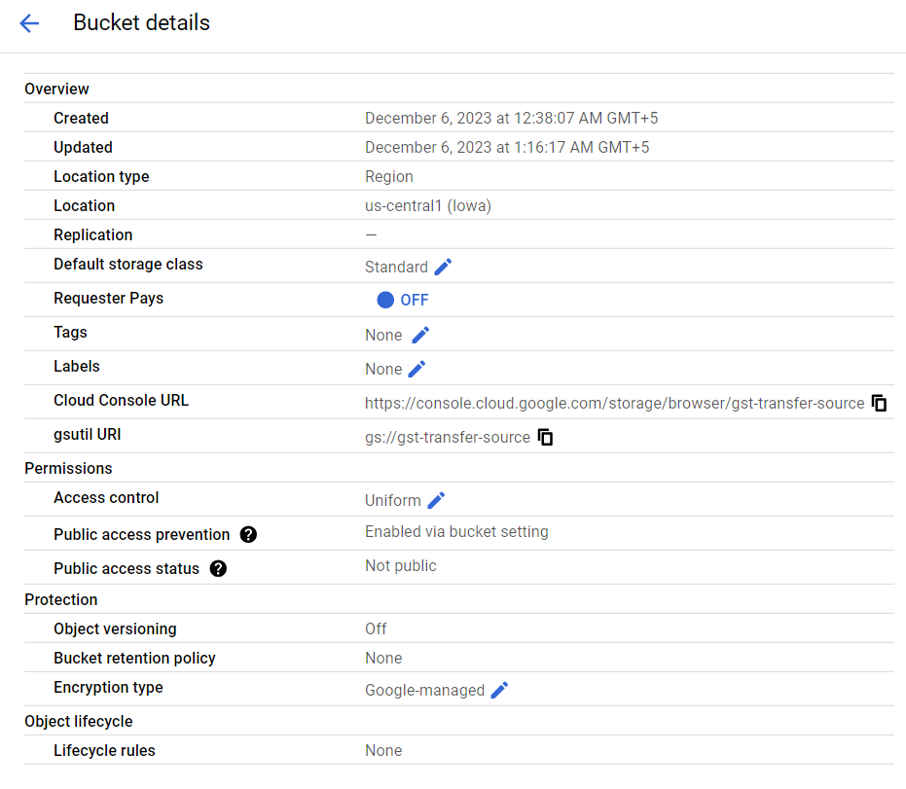

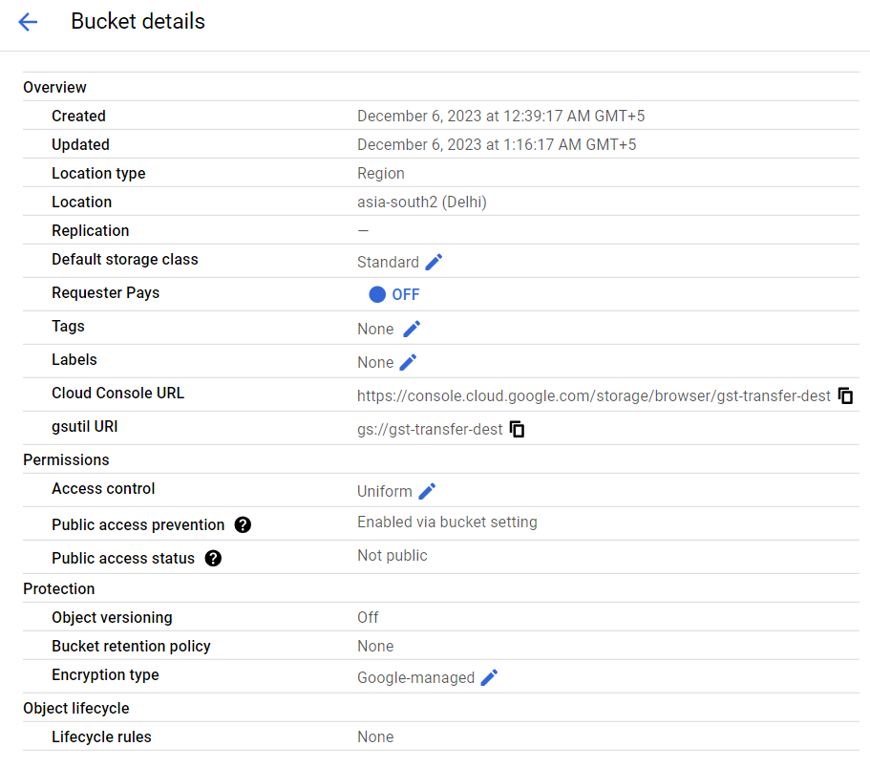

* Then we will create a Pub Sub notification on source bucket so that whenever a new file is uploaded or updated then a message will get published in the topic and will create a subscription also.

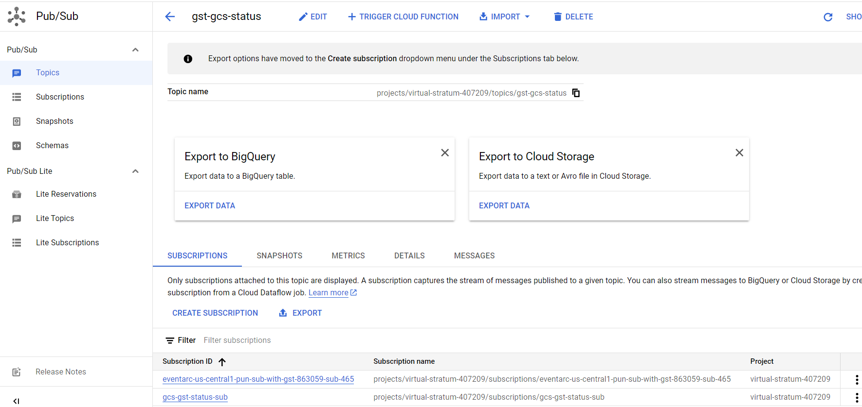

* After this we will go to Storage Transfer Jobs API and will create a new job.
* As we are transferring data from GCS to GCS, so will select that as source and destination type and also, we will select event driven to transfer data whenever a new file is added on the source.

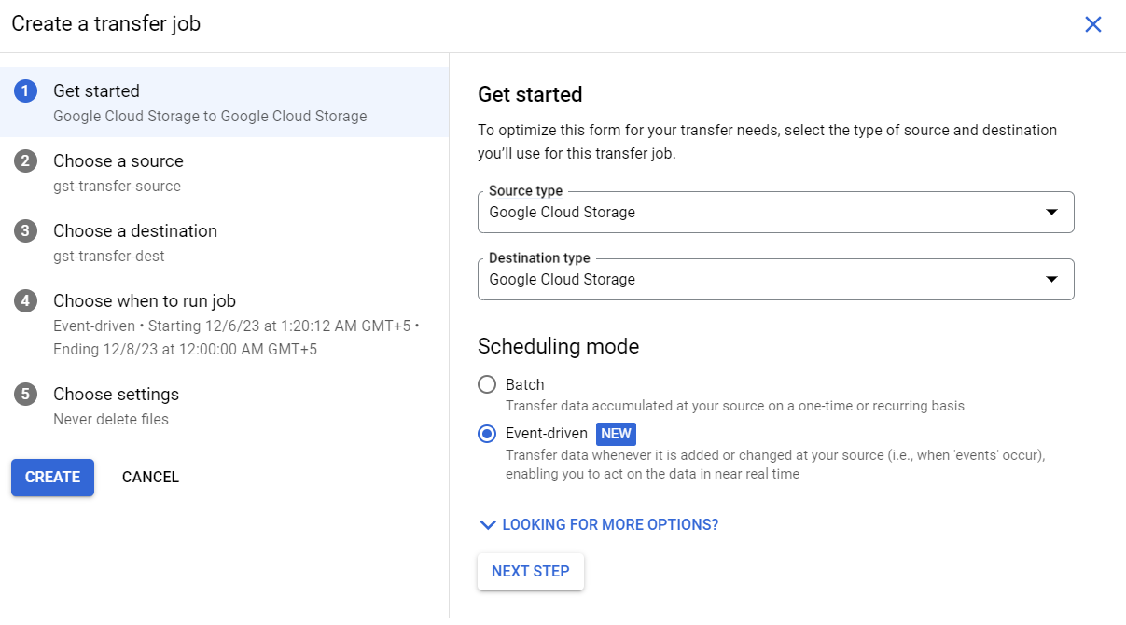

* Then we will select the source and provide the subscription we have created in previous step.

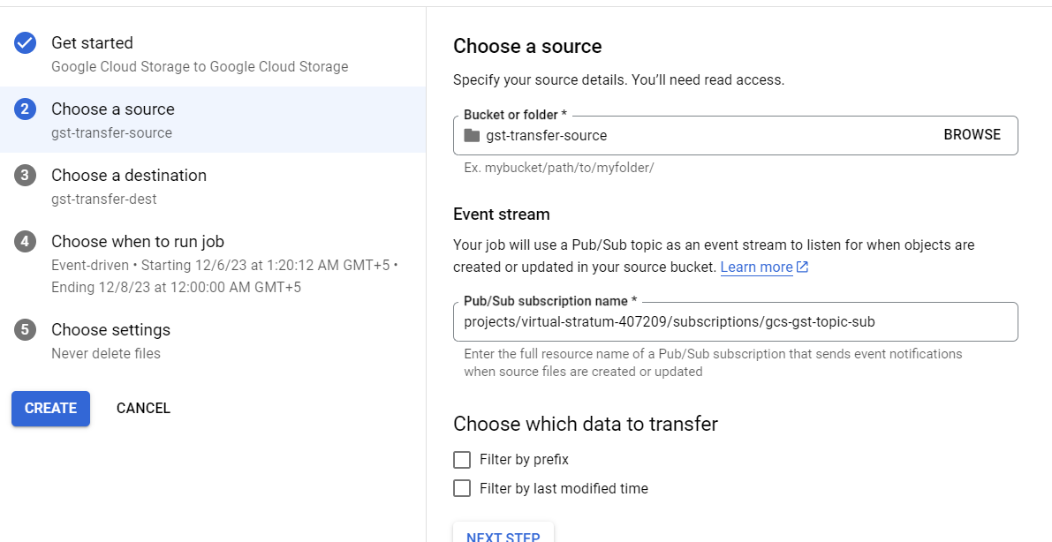

* Then I will select the destination.

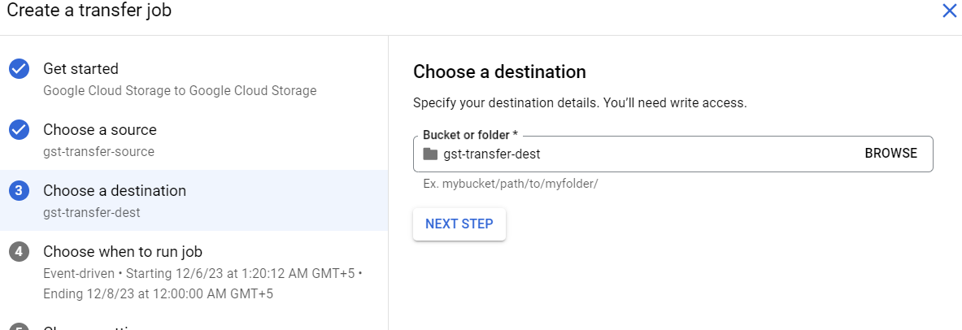

* Now I will select the timing at which I want to run the job.
* After this I will create a new topic in which I want to publish the message regarding the status of the job.  
  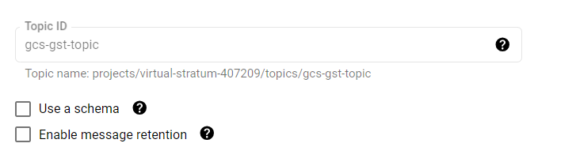
* Then I will provide this topic in my job settings in fifth step:  
  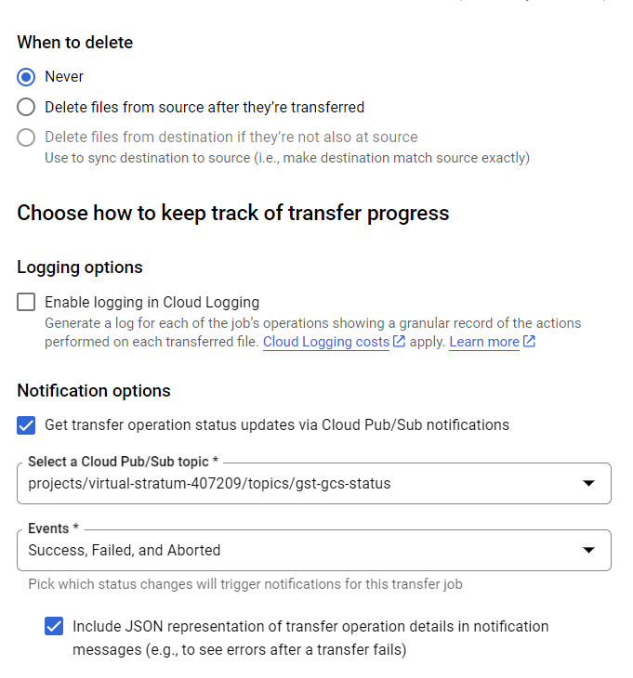

After creation, when we run the job then it will wait for a new file to come in GCS and after that a message will get publish in pub sub topic, then the job gets triggered and it will copy the data to destination and publish the status message into topic which we can use for further integrations.

